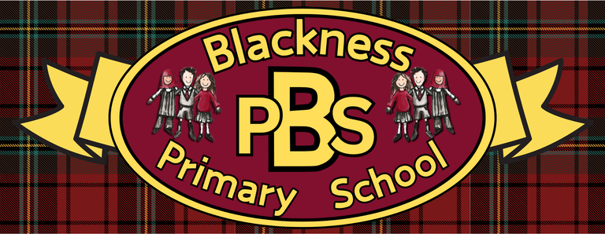 “Everyone Here Matters”
Primary 7 Health and Wellbeing Grid
Developing Healthy Choices  Keep a food diary for a day. Investigate whether what you ate has more or less than the recommended sugar intake (Ages 11 and up / Adults: Maximum 30g (7 sugar cubes) per day) | Nutritional Needs  What are nutrients and what jobs do they do for our body?  Explore these questions using this link:  What are nutrients? - KS2 - BBC Bitesize | Personal Hygiene  Design a poster that promotes good personal hygience habits for someone your age. | The journey of food  Choose a food item that you regularly eat. Find out where it is grown/produced and chart the journey it takes. How many food miles is its journey? What possible impacts can you think this may have on the environment?
Food technology  Prepare and cook a savoury dish using a range of preparation/cooking techniques. Have your family score your efforts like Masterchef judges! | Physical activity  Create a new game or sport including a list of the required equipment and instructions on how to play. | Social Wellbeing  Wellbeing activities: being kind to yourself  Watch the web of connections video clip and complete the activity. | Zones of Regulation  Describe the impact being in the blue, yellow and red zone might have on our bodies. What would that look like to other people? How would it feel internally?
Healthy Relationships  Write a guide to developing strategies to manage disagreements, share decisions, and resolve arguments calmly for younger children. | Mental and Emotional Wellbeing  Create an "I Am..." display poster where you draw or write down personal strengths and encouraging statements. Use this as a reminder/support in times of stress/worry. | UNCRC  Create a news report from somewhere in the world where you feel the Rights of a Child aren’t upheld. Explain what right is being violated and the impact that may have on those children’s health and wellbeing.  . | Online Safety  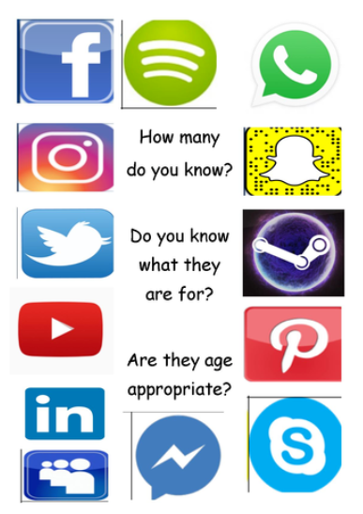  Social Media  Find out the recommeded age for these platforms. Do you agree with what they are?

Ready Respectful Safe

Ready Respectful Safe

