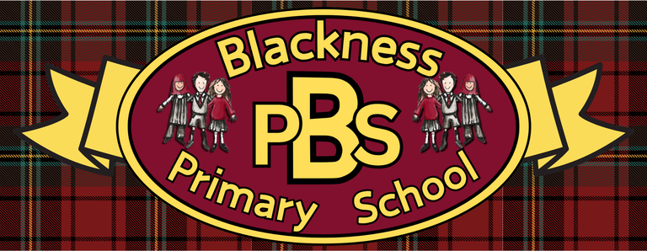 “Everyone Here Matters”
Primary 6 Health and Wellbeing Grid
Developing Healthy Choices  Use the table below to record the amounts of sugar in a variety of different drinks.  List them from healthiest to unhealthiest. | Nutritional Needs  Deepen your understanding of food allergies and intolrances. Think about how the school can help support pupils with these conditions.  Why do people eat different things? - BBC Bitesize | Personal Hygiene  Design a new deoderant range that is aimd towards young teens. Think about a catchy name, the smell and packaging. | The journey of food  Plant seeds like peas or beans, experimenting with different levels of light, water, and temperature, and track the growth stages.
Food technology  Practice the "bridge" and "claw" grips using soft fruits like bananas or strawberries  https://youtu.be/MmYadhbZ7bA | Physical activity  Design a new tig game you could use as a warm up in your PE lessons. Make sure you have a list of equipment and clear rules. | Safety  Use the THINK! Road Safety resources for KS2 to plan a safe walking or cycling route to school, identifying potential crossing spots and discussing distractions like mobile phones. | Zones of Regulation  Create a character for each zone that could help introduce the Zones of Regulation to younger children.
Healthy Relationships  Design a monthly calendar or daily prompt sheet filled with small acts of kindness you can do for classmates, friends or family members. | Mental and Emotional Wellbeing  Growth Mindset  KS2 PSHE: How your mindset can affect your approach to challenges - BBC Teach  Think about how you can change your mindset towards challenges you currently avoid. | UNCRC  Read the scenarios below and think about what Rights of the Child are being denied. | Online Safety  Which of these are safe to share online?  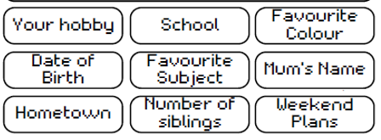  Explain your reasoning.

Ready Respectful Safe

Ready Respectful Safe

