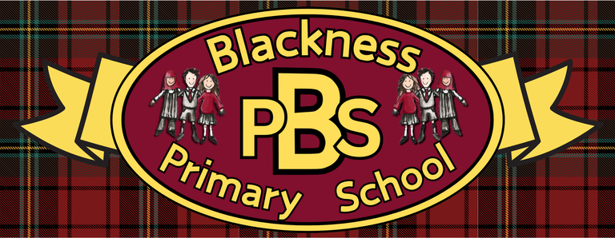 “Everyone Here Matters”
Developing Healthy Choices  Rainbow Challenge  Try to eat a different coloured fruit or vegetable every day of a week! | Nutritional Needs  Design a Healthy Snack: Can you create a balanced sandwich combining multiple food groups? | Keeping safe  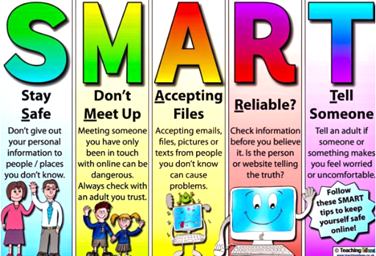  Can you design a poster that shares these messages for younger classes? | The journey of food  Can you annotate the flow chart below with pictures that match the steps in the journey.
Food technology  Food Labelling: Can you investigate five different products that are kept in the fridge. Look at the storage instructions, and the difference between use-by (safety) and best-before (quality) dates. | Physical Activity  Can you make up your own circuit either indoors or outdoors that will help improve your fitness? | Wellbeing  Take some photos of people and things that are important to you. Could you display these in different ways? | Zones of Regulation  Which strategies work best for you for each zone?  Add some of your own strategies to the list for each zone.
Healthy Relationships  Think of something that you could do to help an older relative or neighbour. Could you surprise them with a kind action? | Mental and Emotional Wellbeing  Write a letter to yourself in a week, month or year. What goals do you hope to achieve by the time you read your letter again? | Mindfulness  Listen to some relaxing sounds (e.g. rainfall, beach sounds, rainforest soundtracks). How do they make you feel? This Youtube channel has lots of examples. | UNCRC  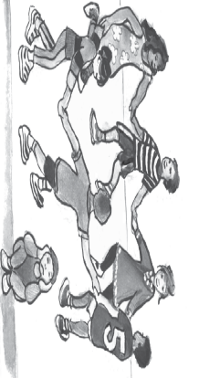  What rights are being met/not met in this image?

Ready Respectful Safe

Ready Respectful Safe

