 “Everyone Here Matters”
P1 Health and Wellbeing Grid
Developing Healthy Choices  Design a fruit kebab that has at least 4 different fruits. Explain why you have chosen those fruits (think about smell, taste, texture etc). | Nutritional Needs  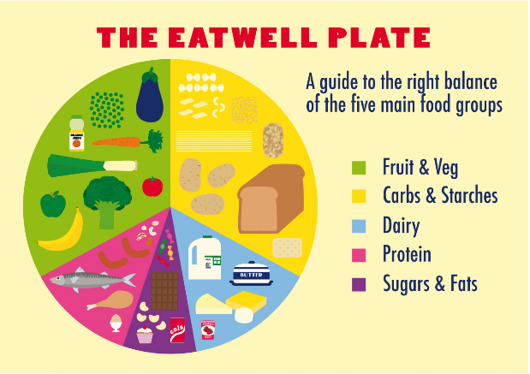  Can you find examples of all of these food groups in your fridge or cupboards at home? | Keeping safe/hygienic  Have an adult record you washing your hands – explaining the steps you have taken to make sure they are clean. | The journey of food  What is your favourite fruit? Can you find three different countries where it is grown and how far away these countries are from Dundee?
Food technology  Get involved in the washing, tearing or mixing of ingredients during food preparation. Has this increased your willingness to try some new foods? | Physical Activity  Get moving with these fun activities inspired by some Disney characters.  10 Minute Shake Up games – Healthier Families - NHS | Social Wellbeing  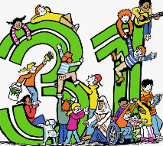  The Right to Play  Article 31 – over the course of a week chart how many opportunities you have had to play. This could be done through a list, diary, drawing pictures or taking photographs. | Zones of Regulation  Decorate your own feelings monster  feelings monster.docx  (if you can’t access the document feel free to draw and decorate your own monster).
Healthy Relationships  Draw a picture of one of your friends. Around the picture write words that share what makes them a good friend. | Mental and Emotional Wellbeing  Carry out a random act of kindness for a member of your family. | Staying Safe  Talk to your adult about what you would do in different emergencies. | Online Safety  Balance screen time with physical activity. For every minute you are on a device spend the same amount of time outside.

Ready Respectful Safe

Ready Respectful Safe

