
Blackness Primary School-
Seesaw (inc. home learning) Policy 2026.27

Seesaw is DCC digital platform used across all settings in Dundee. It is to be used for:
- Evidence of learning
- Sharing learning with families
- Supporting ICT to enhance learning
Within Blackness, Seesaw should be used to communicate learning with home, share successes and store evidence of learning.
Each class should have 3* Ipad’s to support uploading and recording of work.
Both the pupils and teachers can upload work using individual and class QR codes.

Blackness Min. Expectations
- At least 2 posts per child per week (whole class, group or individual).
- RCT staff to upload evidence of work for relevant classes (week A and B rota for coverage of classes).
- Ensure there is a mixture of “doing” pictures and learning achieved/evidence pictures.
- All members of team that teach and support class to have access to class and be involved in posting. (Teachers, RCT, support staff, RWI staff, SLT, Emma, Frances)
- All posts to be categorised into folders. (Appendix 1).
- Look for opportunities to send good news home.
- Weekly information about class learning – a statement for literacy/maths/health and well-being posted using the Blackness template (appendix 2).
- Useful websites to be added to each class SeeSaw – these can be used at home to reinforce literacy/numeracy or other areas of the curriculum.
- Home learning will to shared via SeeSaw for every year group on a weekly basis.
- Seesaw poster displayed clearly in class (at pupil level). P1-2/3 cohorts to use visual sentence starter prompts and P3-7 to use the laminate sentence starter prompts. (appendix 3).
- QR codes linked to seesaw evident in displays throughout your classroom.

Optional: Seesaw lessons to be used in class where necessary and for extension activities.

Home Learning
Home learning will be shared via SeeSaw for every year group on a weekly basis. The following steps show the consistent approach that will be taken across the school P1-7.

- Home Learning shared on a Thursday and submitted by the following Thursday.

- A learning grid will be used to share home learning – one piece of work will be completed from the grid each week.

- In addition to this spelling/phonics, reading or numeracy practice should be shared regularly.
e.g., spelling or phonics practice words/sounds, reading via Oxford Owl/Sumdog competitions or other maths games
- Weekly information or reminders to be posted for each class (e.g. trips/visitors/ special activities/reminders)
- Feedback Friday - general feedback comment giving recognition of efforts made with homework.
- Feedback Friday - Time in class to review home learning tasks submitted celebrate/share achievements/go over any areas that require further input.

Appendix 1: Seesaw Folder Organisation

To be organised in curricular areas:

Literacy | Red
Numeracy | Blue
HWB | Light Green
Learning across the curriculum | Yellow
Wider Achievements | Pink
Homework | Grey
Announcements | Orange
Nurture | Lilac
Active Schools | Dark Green
Other | Navy

Appendix 2: Weekly information grid

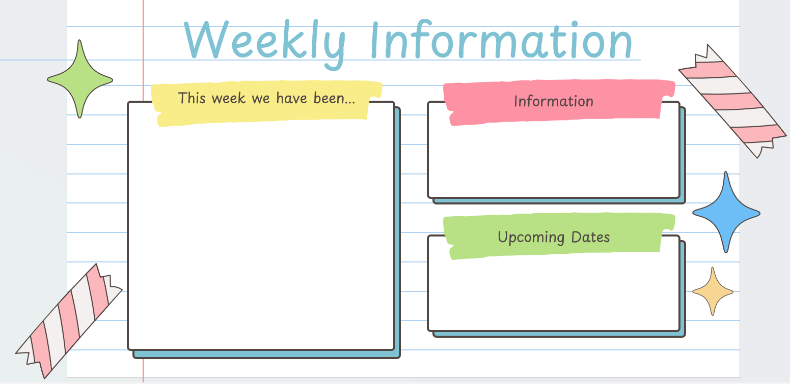

Appendix 3: Seesaw poster and prompts

